Name\Ghada Moustafa Saber

## B.N\561

Date\10\6

Topic\ Artificial intelligence

Application Brief\Artificial intelligence (AI) is intelligence demonstrated by machines, unlike the natural intelligence displayed by humans and animals

Screenshots\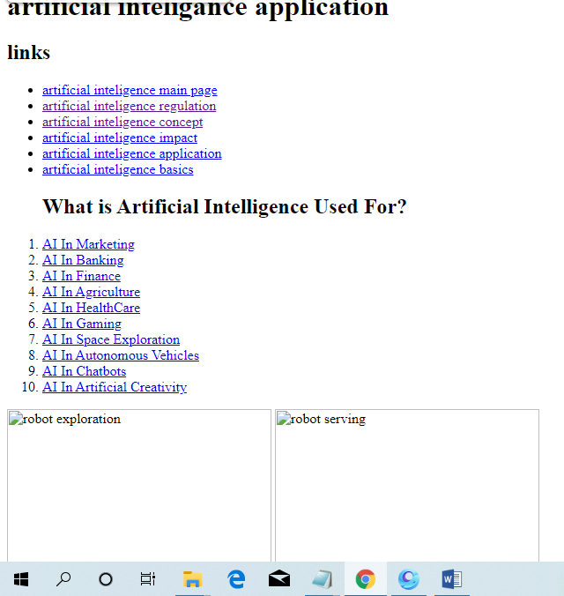

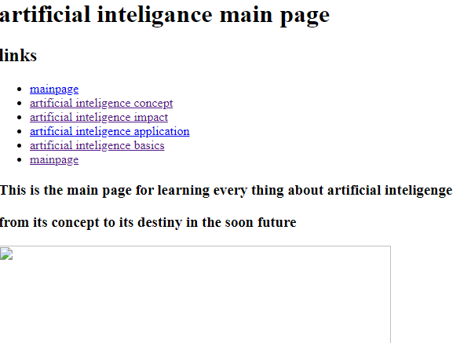

SOURCE CODE\